Aviral Rajput

CSS GRID ASSIGNMENT REPORT

Contents

Introduction 2

Web Page 2

Responsive design and media queries 3

Navigation 12

CSS 13

Conclusion 14

# **Introduction**

The aim of this assignment is to get the proper understanding of CSS grid layout and media query to make a web page responsive. Grid Layout gives us a method of creating grid structures that are described in CSS and not in HTML. It helps us to create layouts that can be redefined using Media Queries and adapt to different contexts.

Grid Layout lets us properly separate the order of elements in the source from their visual presentation. As a designer this means you are free to change the location of page elements as is best for your layout at different breakpoints and not need to compromise a sensible structured document for your responsive design.

# **Web Page**

This is my web page and the first page the user will see when they run the “assignment.html”. It has navigation menu redirecting the user to other grid examples, a calculator to calculate digits. All distributed into grid partitions with header, nav, aside, footer and one user defined area.

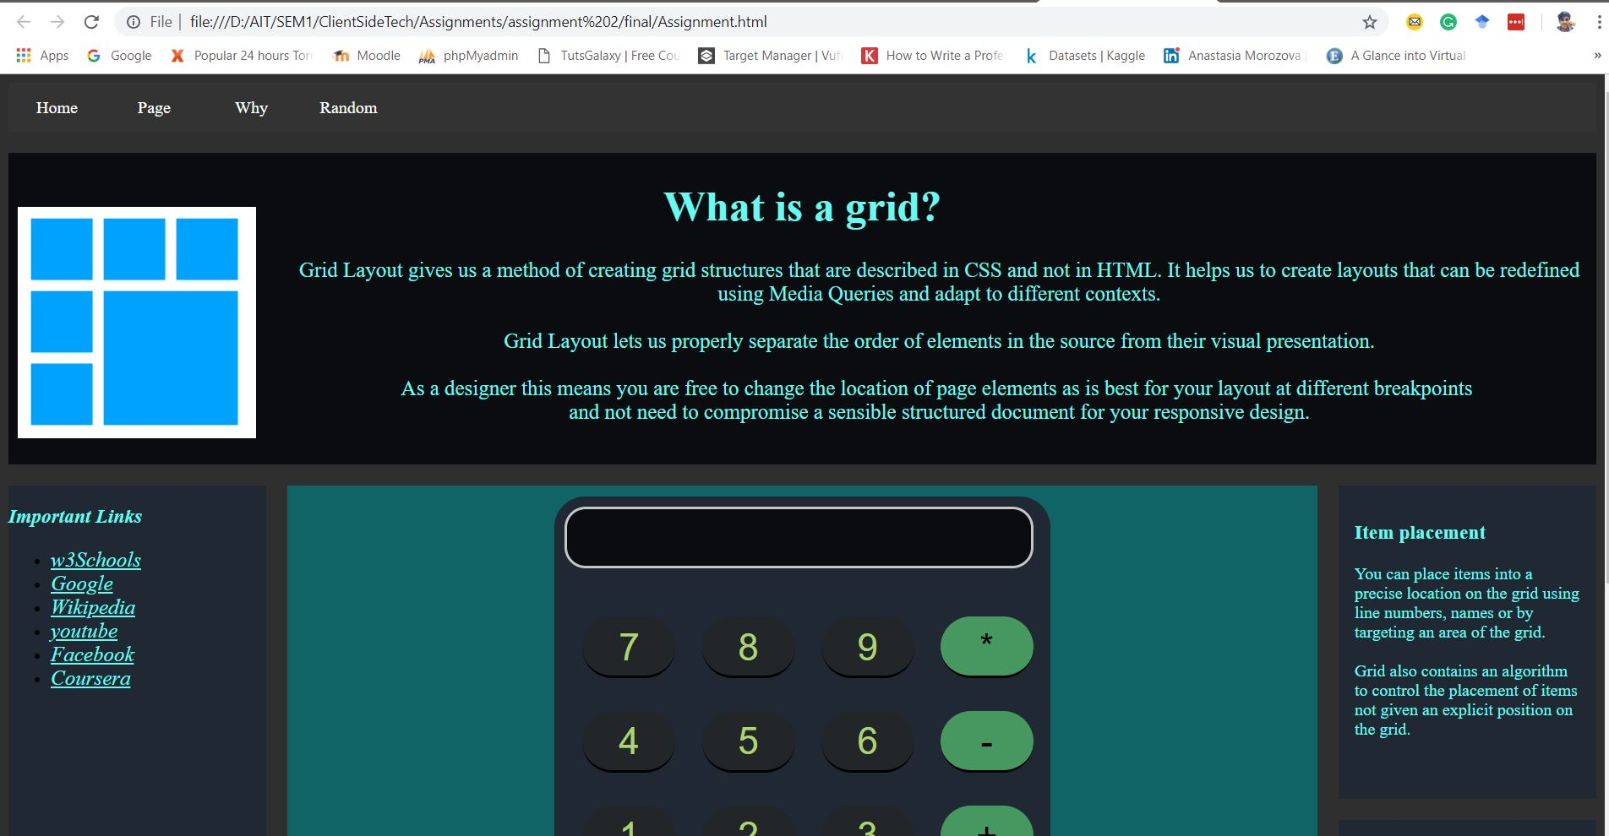

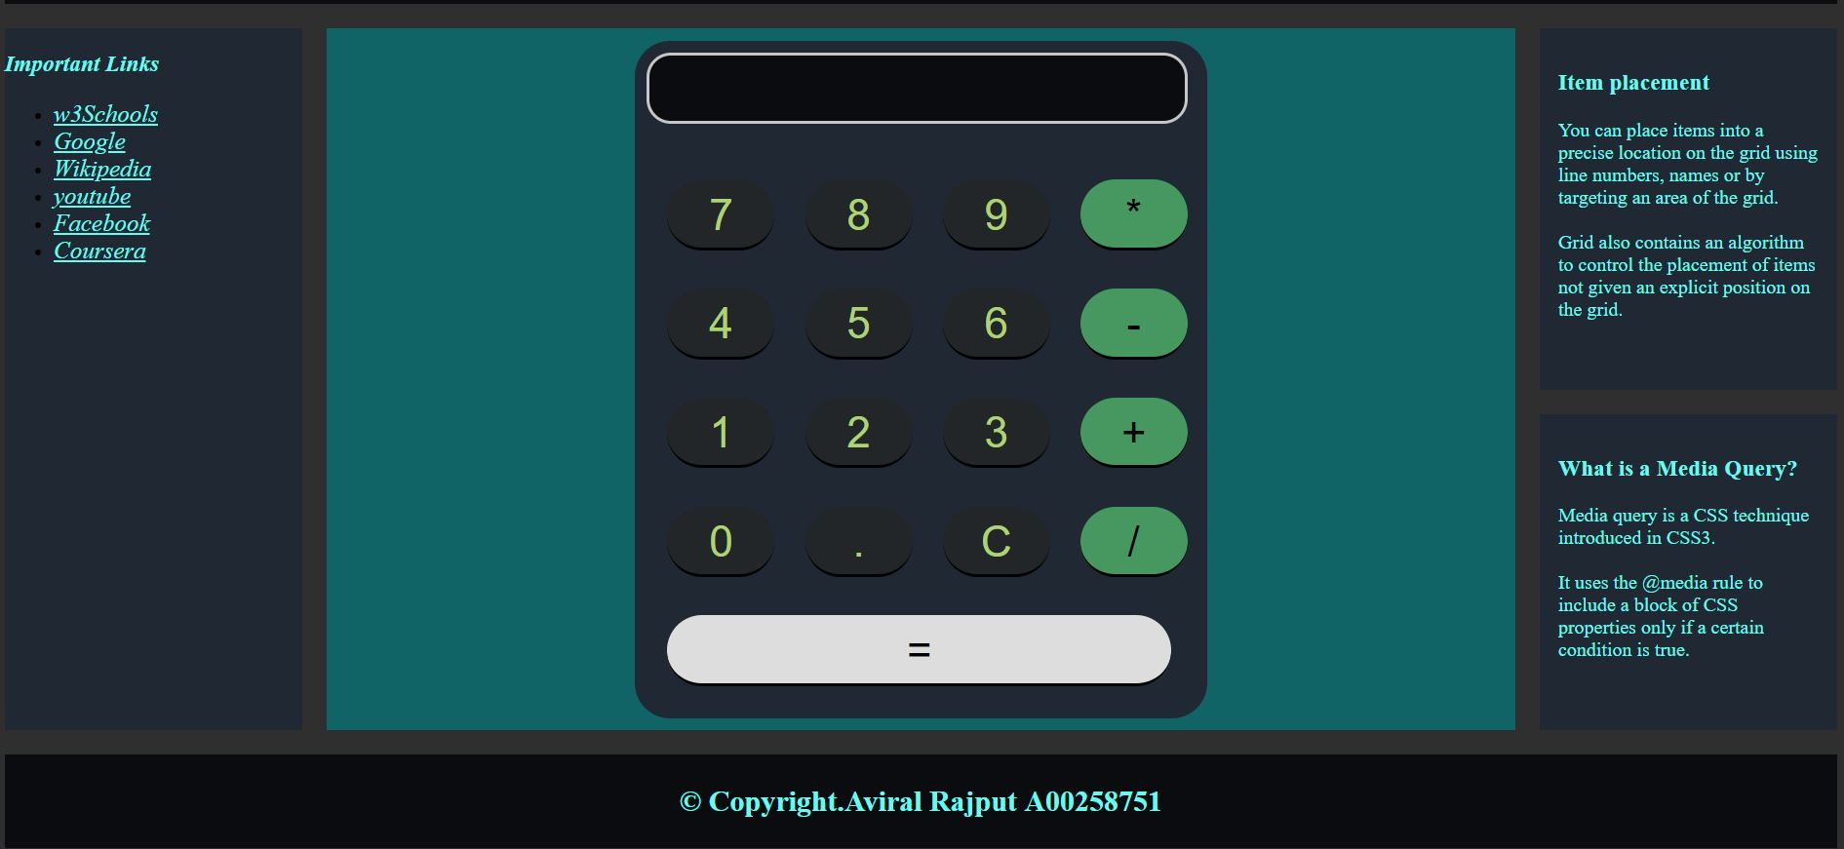

*A calculator to manipulate digits when user click on desired button*

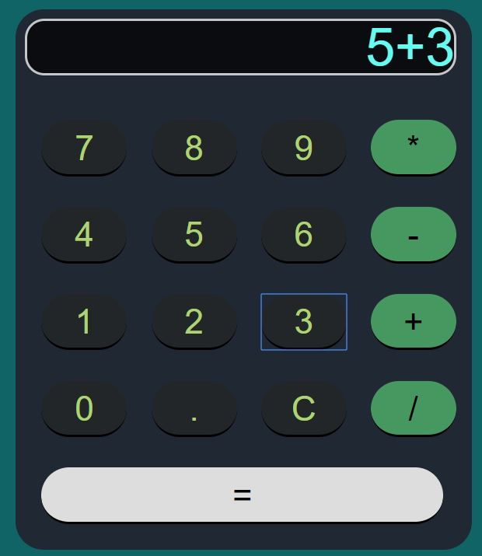 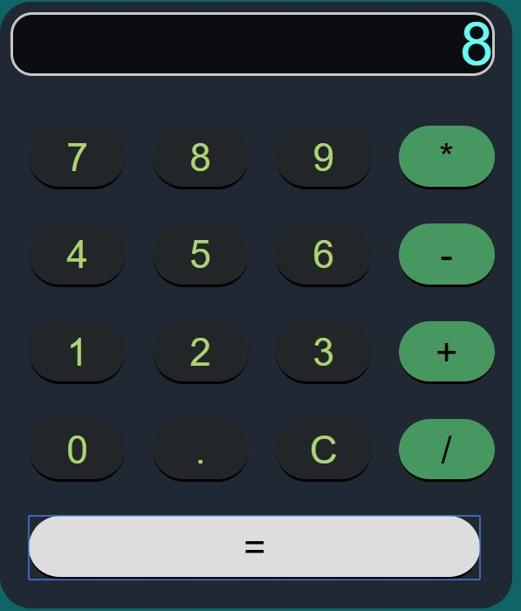

# Responsive design and media queries

To make the web page responsive I have added the grid layout and divided it into different sections and then used media query to add break points to apply different styles for different media types/devices.

Media queries can be used to check many things, such as:

* width and height of the viewport
* width and height of the device
* Orientation resolution

Using media queries are a popular technique for delivering a tailored style sheet (responsive web design) to desktops, laptops, tablets, and mobile phones.

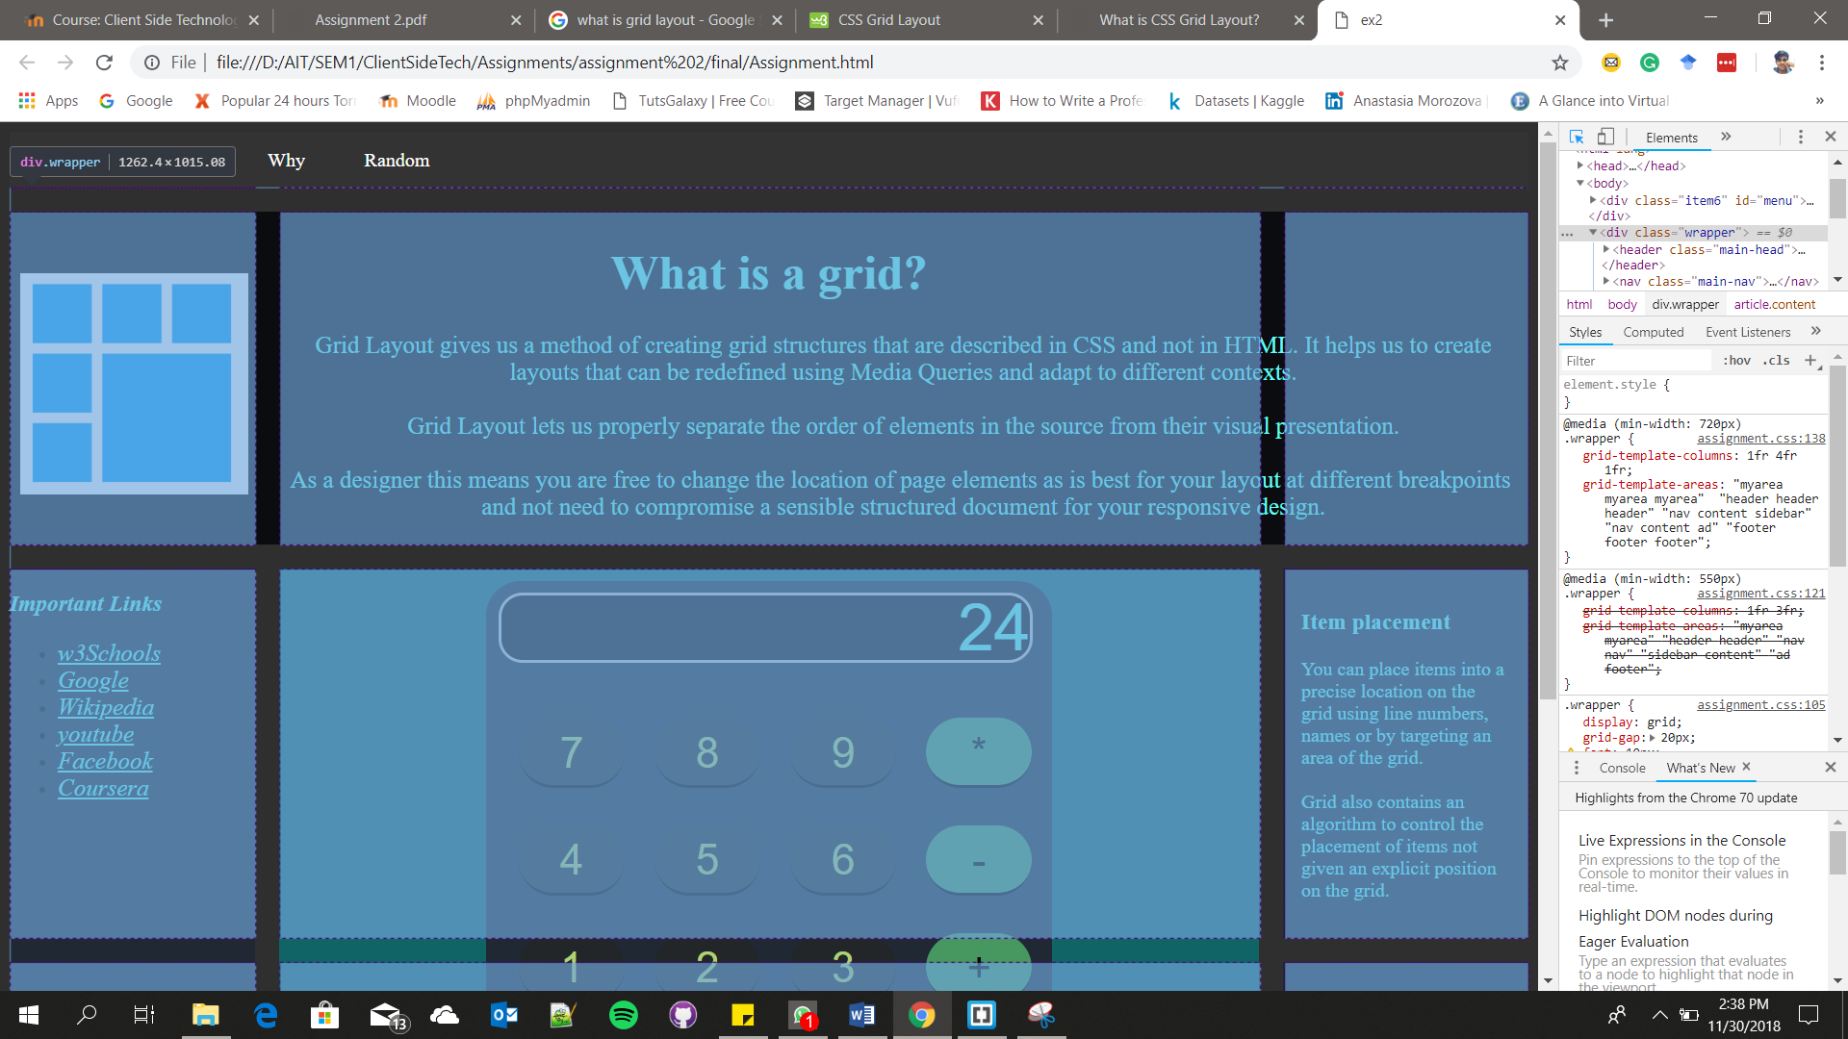

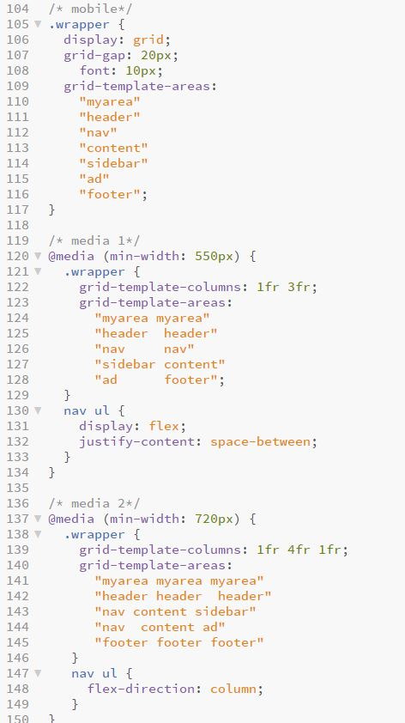

* **Media query for default**
* **Media query break at 550px**
* **Media query at 720px**

I used media query for 3 different width and changing the container size and the element style under the container.

I placed 3 images based upon breakpoints so that on every breakpoint image would change



***For media size less than 720 px***

***The image od gri changed and the formation of grid contents changes from***

"myarea myarea"

"header header"

"nav nav"

"sidebar content"

"ad footer";

"myarea myarea myarea"

"header header header"

"nav content sidebar"

"nav content ad"

"footer footer footer"

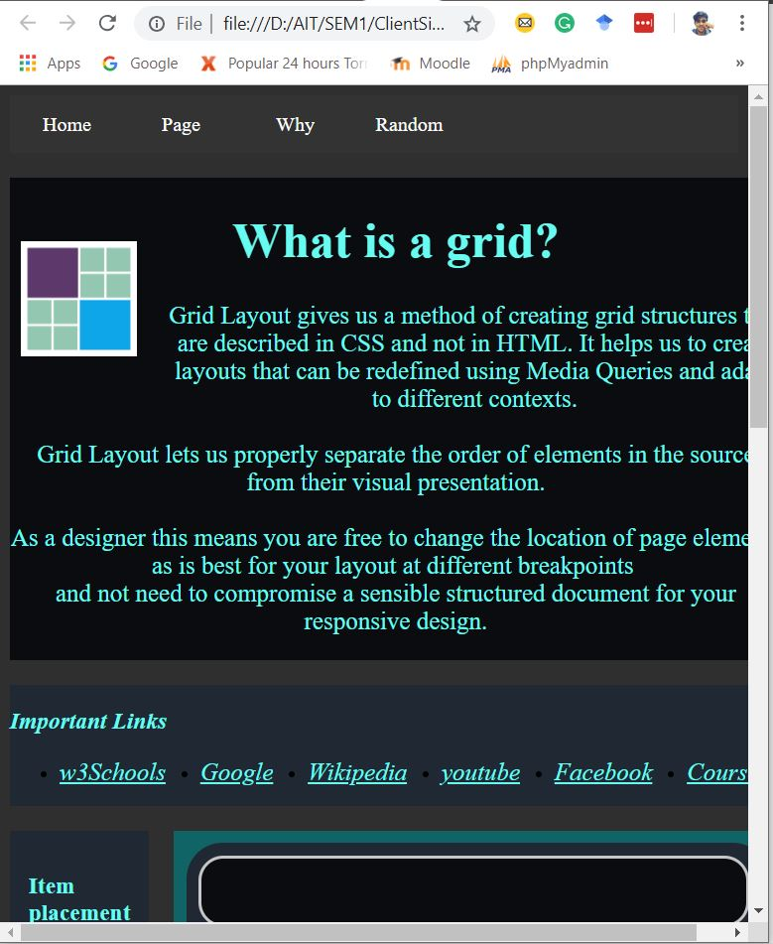

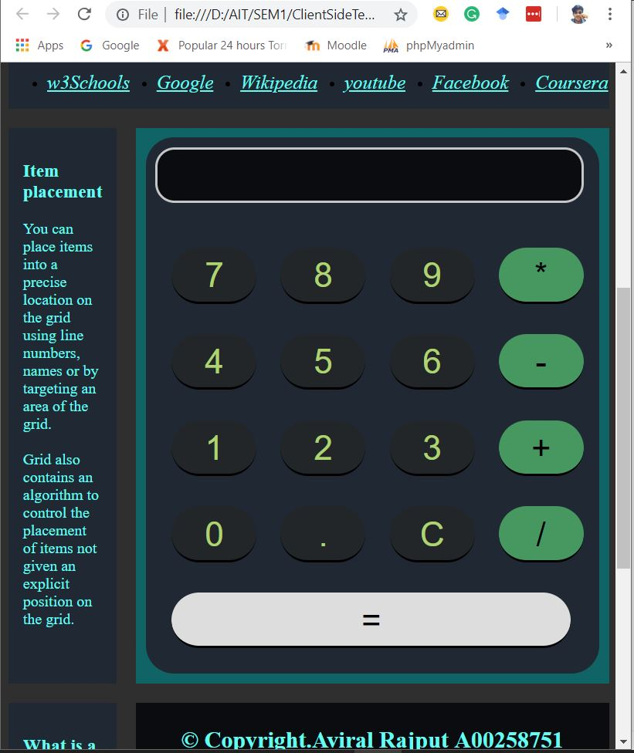

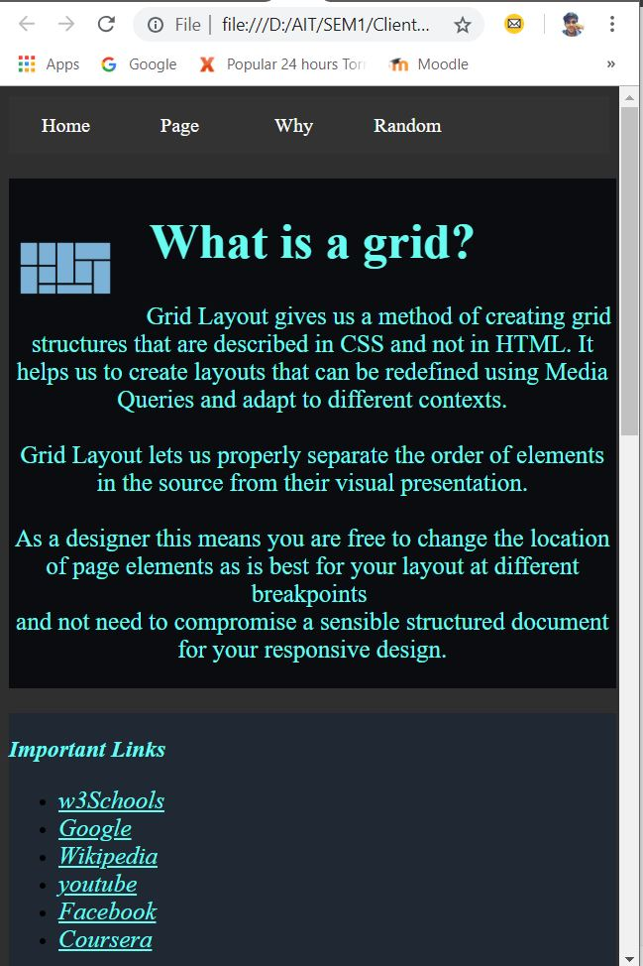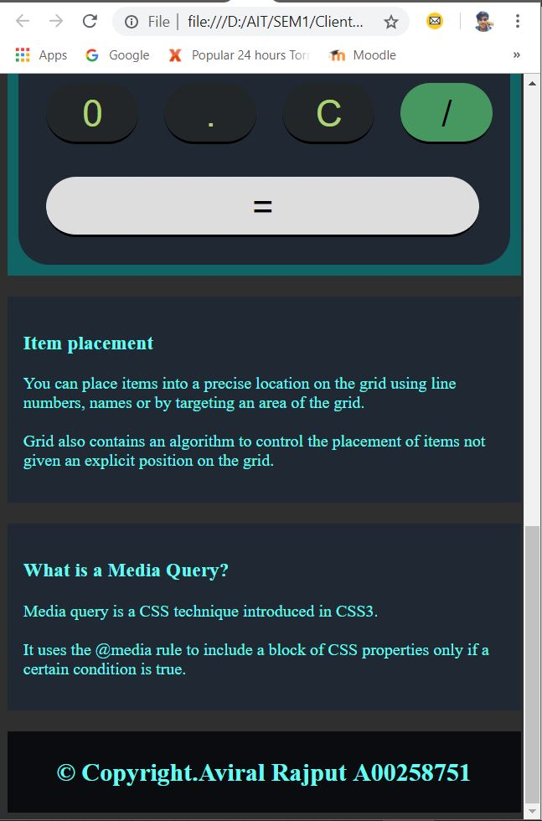

*"myarea"*

*"header"*

*"nav"*

*"content"*

*"sidebar"*

*"ad"*

"footer";

*"myarea myarea"*

*"header header"*

*"nav nav"*

*"sidebar content"*

*"ad footer";*

Here the media Query changed to less than 450px and the container elements in the List changed to singular element

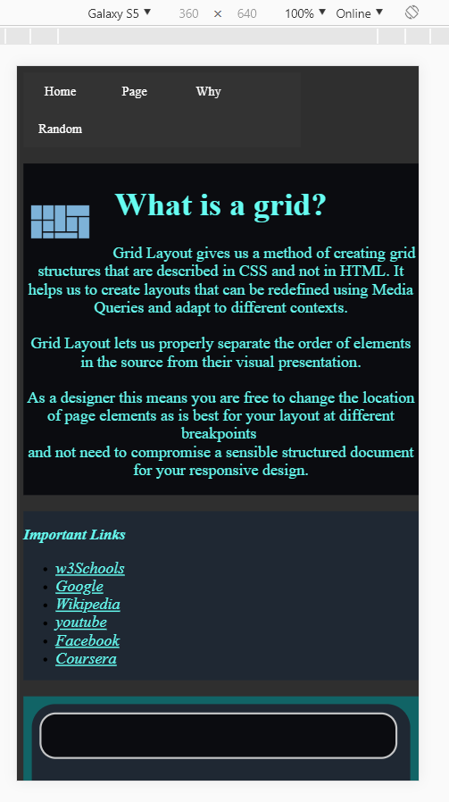

**Grid layout for Galaxy S5**

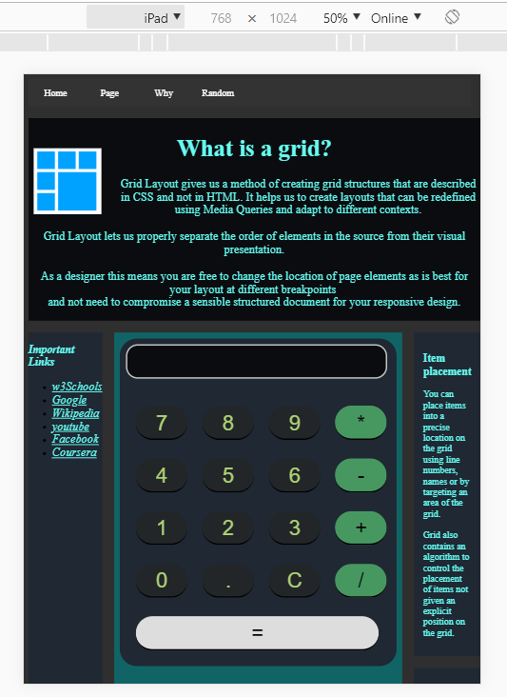

**Layout For iPad**

# **Navigation**

With the use or ordered list I created a navigation menu on a user defined grid element and added different grid examples to indicate the working.

I have added different examples of grid and added video **URL** also in other examples different types of grid layout.

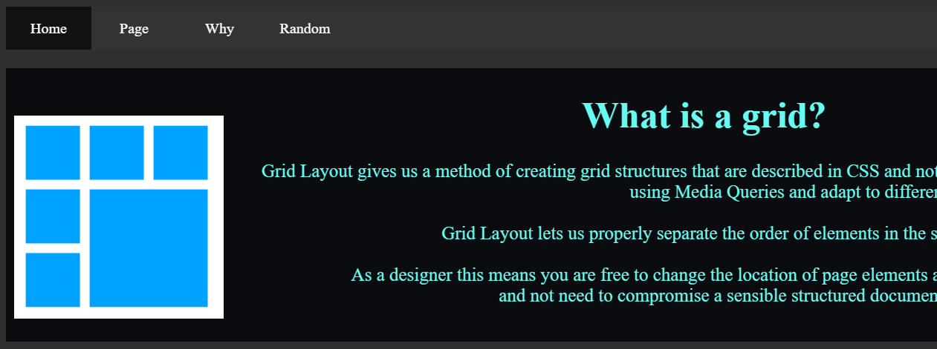

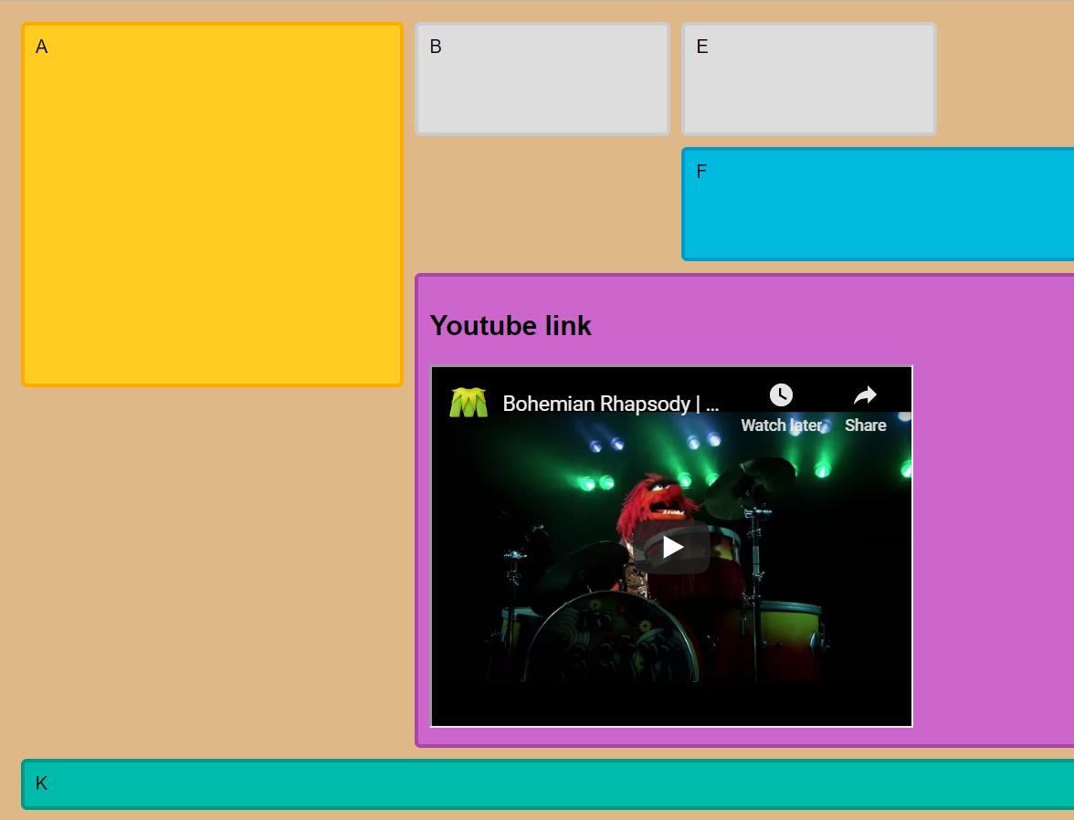

# **CSS**

*I implemented just some basic CSS to display that I have learned from the labs. I implemented*

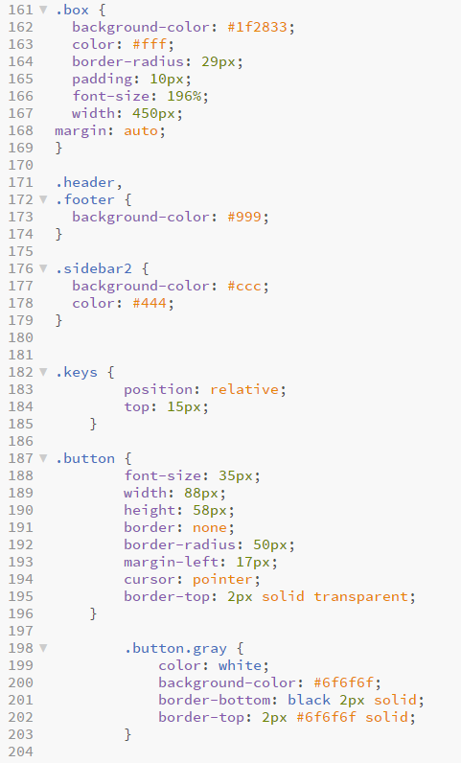

# **Conclusion**

I learned the true meaning of responsive website from this assignment also I learned that it is important to make website responsive so that it could run on different devices.

This assignment helped me to refresh my skills and I enjoyed this assignment and hope to build more assignments like this this will help me in future assignments and other projects.

# **References**

* Css Grid – [w3School](https://www.w3schools.com/css/css_grid.asp)
* Css Grid crash course : [Youtube](https://www.youtube.com/watch?v=jV8B24rSN5o&t=1s)
* [Codepen](https://codepen.io/MSEdgeDev/pen/mMQqZX) grid examples for demo
* Redefining [media queries with grid](https://gridbyexample.com/examples/example13/)